Fetching Netsuite data on chatgpt
Step 1 :
Go to Setup < Company < Enable Features.
Mark “True” - below the Manage Authentication Check box under suite cloud sub tab.
To Verify :
Go to Setup < Integration < Manage Authentication Sub Tab
You Can See the List of Components
Add the below Compenents on intergration role under setup subtab.
1. OIDC Provider Setup
2. OpenID Connect (OIDC) Single Sign-On
3. Set Up OpenID Connector IDC) Single Sign-On
4. OAuth 2.0 Authorized Applications Management
5. MCP Server Connection
6. Set Up SAML Single Sign-on
Remove : SAML Single Sign-on
Step 2 :
Go To Chat Gpt
Go to Apps < top right corner click on settings icon
Apps < Advance Settings < Developer Mode < ON
Create App < Enter Any Name < In MCP Url – Enter Netsuite Link
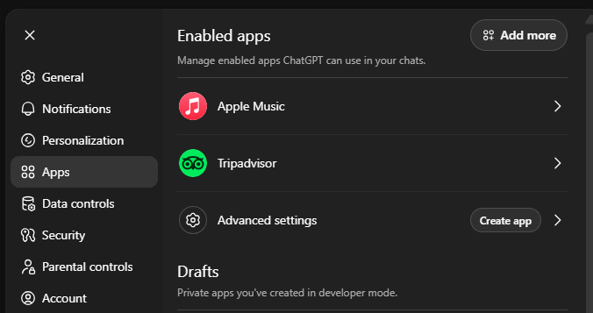
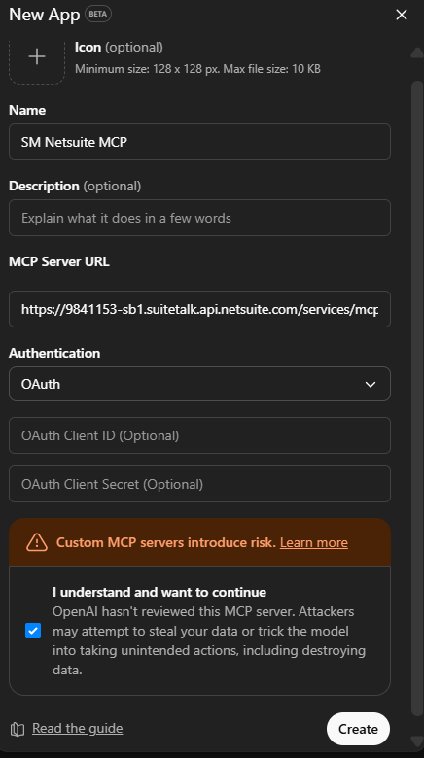
(For eg: https://9841153-sb1.suitetalk.api.netsuite.com/services/mcp/v1/all) < Create
let method oauth, then save.
Final Step :
Follow netsuite authentication prompt permission grants in browser, and then you have connected netsuite to chatgpt !

